Practical No. 1

Creating a Web Service using .NET

**Steps:**

1. Control panel > programs and features
2. Turn on windows features >
3. Check Internet Information Services, and check all things inside it
4. Check Information Services Hostable Web Core, and check all things inside it
5. Visual Studio start new project
6. Choose asp.net web application (.net framework)
7. Uncheck for configure for https
8. Click on empty project and then create
9. Add > new item > web service (.asmx file)
10. Run the web service
11. On web page invoke the function
12. Add > service reference >
13. Click on advanced >
14. Click on add service reference >
15. Start browsing for web service >
16. Click this solution >
17. Give any name > add web reference
18. Use the object in code-behind to use the web service

**Q.1]** Create a Web Service for displaying “hello world”.

**Code [defaultmain.asmx.cs]:**

public class defaultmain : System.Web.Services.WebService

{

[WebMethod]

public string HelloWorld()

{

return "Hello World";

}

[WebMethod]

public string CheckEvenOdd(int num)

{

if (num % 2 == 0)

{

return "Number is even";

}

return "Number is odd";

}

}

**Output:**

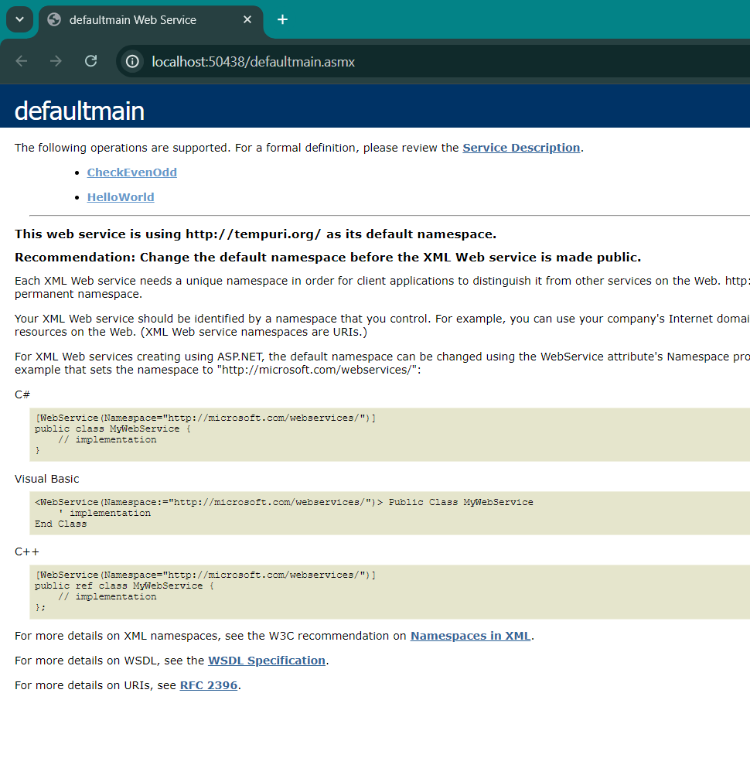

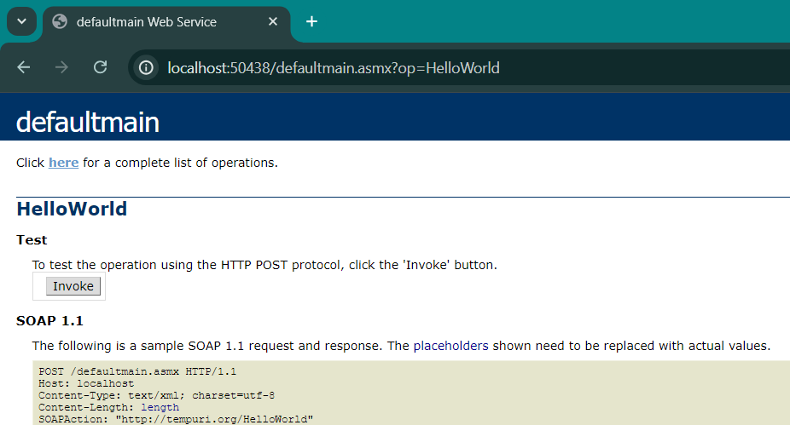

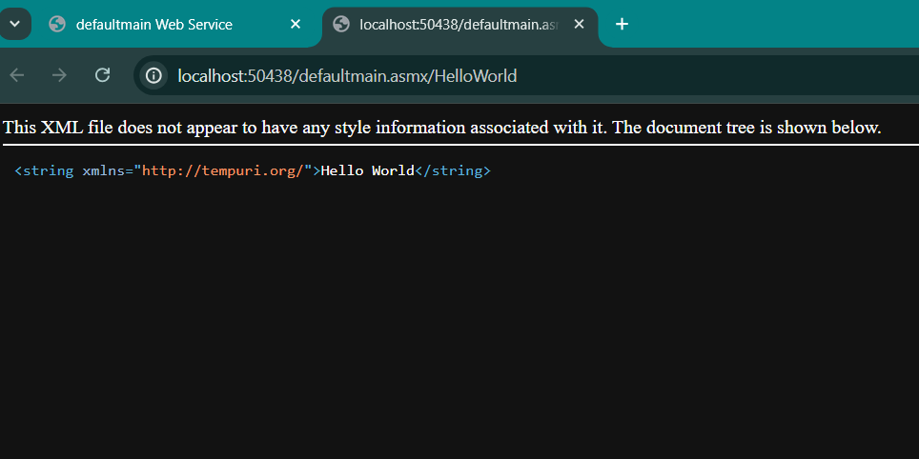

**Q.2]** Create a Web Form and a Web Service for an even-odd function in the same project.

**Code [EvenOddWebForm.aspx.cs]:**

public partial class EvenOddWebForm : System.Web.UI.Page

{

protected void Page_Load(object sender, EventArgs e)

{

}

protected void Button1_Click(object sender, EventArgs e)

{

defaultmain webService = new defaultmain();

int number = Int32.Parse(input1.Text);

resultLbl.Text = webService.CheckEvenOdd(number);

}

}

**Output:**

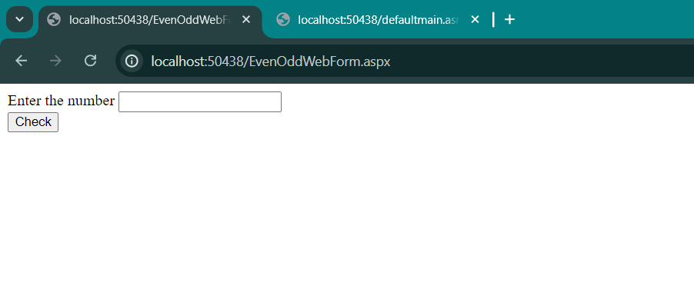

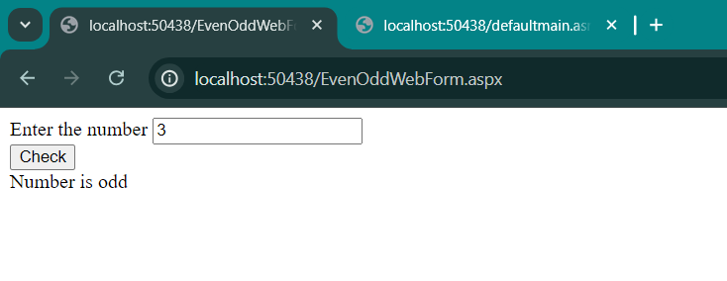

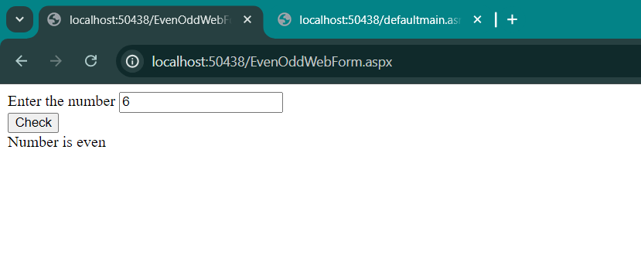

**Q.3]** Consume the even-odd Web Service in a different project.

**Code [MainForm.aspx.cs]:**

using System;

using System.Collections.Generic;

using System.Linq;

using System.Web;

using System.Web.UI;

using System.Web.UI.WebControls;

using webservicesp1n2.EvenOddWebService;

namespace webservicesp1n2

{

public partial class MainForm : System.Web.UI.Page

{

protected void Page_Load(object sender, EventArgs e)

{

}

protected void Button1_Click(object sender, EventArgs e)

{

defaultmainSoapClient webService = new defaultmainSoapClient();

int number = Int32.Parse(input1.Text);

resultLbl.Text = webService.CheckEvenOdd(number);

}

}

}

**Output:**

